1. Soil C pool data was calculated from bulk density and C%. (Table 1, page 718).

The paper does not report carbon density directly. We calculated carbon density from Table 1, which reported bulk density and percent organic carbon, but not carbon pool.

Soil C pool = Bulk density \* C%.

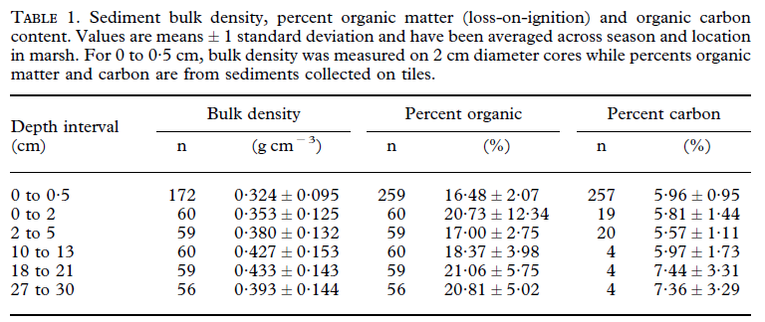

2. The soil carbon rate data was found from the text (page 723).

